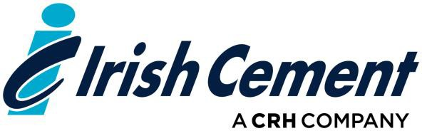

Chemical Engineer

Irish Cement Limited is seeking to recruit a Chemical Engineer to join its Production Process team. The successful candidate will be based in Platin Works, Drogheda, Co. Louth and will report to the Production Manager.

Purpose:

The key responsibilities of the position are to provide technical assistance primarily for the production, but also for the maintenance departments, including but not limited to:

* Crushing and grinding (comminution) equipment
* Process performance including heat transfer applications, material/mass balances and process design
* Kiln Performance and Quality control issues
* Performance Monitoring and continuous process improvement
* Relevant Health and Safety issues

The role requires a strong technical background to interact with various departments at all stages of the production process.

Other Duties are as follows:

* Assist with projects and process improvement assignments
* Responsible for directing contractors on specific jobs or projects
* Assist with kiln overhauls, project startups and commissioning
* Resolve manufacturing problems and implementation of improvement programs
* Assist in the preparation and maintenance of documented manuals/processes

The above list is not exhaustive. The successful candidate will be expected to perform duties as necessitated by the changing role and the overall business objectives of the Company.

Candidates should ideally possess:

* A minimum of 3-4 years relevant experience in industry, together with a degree or similar qualification in a Chemical Engineering related discipline
* Excellent communication and relationship building skills
* Proven technical skills and business acumen
* Project management experience and skills

Candidates wishing to be considered for this position can submit their application along with a current CV before; to [careers@irishcement.ie](mailto:careers@irishcement.ie) using the subject heading “Chemical Engineer”.

To apply visit; <https://www.irishcement.ie/careers/job-opportunities/>